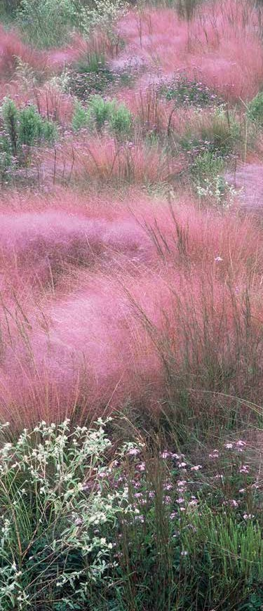

The Katy Prairie Conservancy (KPC) works to protect the coastal prairie for people and for wildlife.
WIDE OPEN SPA CES

KPC’s preserve is the right prairie in the right place. These protected lands play an important role in wildlife habitat, outdoor recreation, and flood control. While KPC has been successful in
protecting more than 20,000 acres west of Houston, there is still prairie that is unprotected. You can help us permanently protect our wide-open spaces before they are lost forever.

A HEAL THY COMMUNITY

Restored prairie grasses absorb and hold back floodwaters and wetlands filter water and improve water quality. Sustainable grazing and prairie restoration ensure that present and future generations have healthier land and healthier watersheds. You can help us make sure our communities are thriving.

AD VENTURE FOR ALL

In America, our open spaces where adventure abounds are disappearing at an alarming rate of 6,000 acres per day. You can help us prevent this as we work to save land and offer outdoor programming on the prairie and in the city.

THRIVING WILDLIFE
9 N ATIVES
FOR Y OUR
GARDEN
Plant for Pollinators

KPC’s preserve system is an important safe haven for birds, mammals, amphibians, and reptiles. The prairie is also home to wildflowers and grasses, insects, and invertebrates. You can help us protect land for people and for wildlife—today and tomorrow.

To learn more and to join us in saving the prairie, visit katyprairie.org.

KATY PRAIRIE CONSERVANCY
5615 Kirby Drive, Suite 867
Houston, Texas 77005
katyprairie.org
713-523-6135
info@katyprairie.org

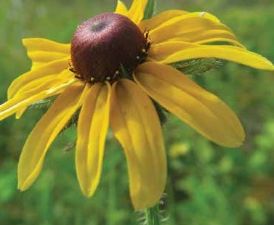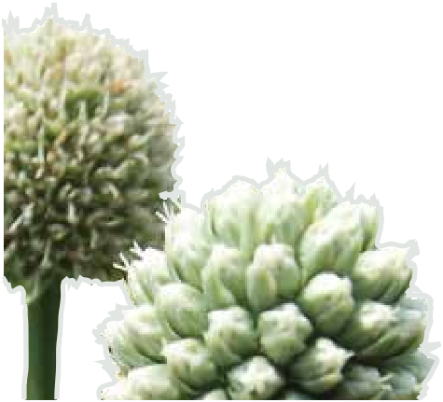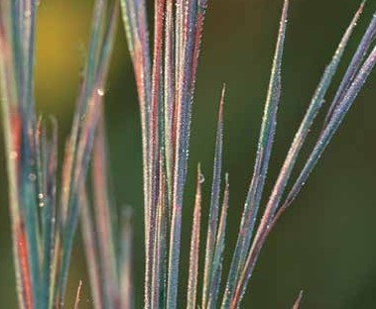
To add the local 9 native plants to an existing bed or to build a new bed for a pollinator garden, follow these simple steps:

1.
SELEC T THE PLANTS .
Most native wildflowers bloom for a short span and then set seeds. For an attractive native plant garden,
install plants with different bloom times to offer a succession of blooms. The 9 natives in this guide have been selected
for these traits; you may wish to
include others.
2.
SELEC T A L OC ATION.
Select a location based on growing conditions. Choose open sites with native soil where the pollinator plants will not compete with tree roots. Chose an area that offers some protection from the wind and that will not be overwatered.

3.
REMO VE EXIS TING VEGETATION.
Various mechanical and chemical techniques exist to remove existing vegetation to create a flower bed. The soil can be covered with clear plastic (solarization) or black plastic
until the existing vegetation dies; treatment may need to be repeated. For a small bed, the existing vegetation can be
physically dug out. For larger area, mow and then treat with chemical herbicide; treatment may need to be repeated to remove all weeds. Tilling is generally not recommended because that might bring weed seeds to the surface.

Alternatively, you may make a raised bed: surround the area with a raised border, cover the area with 8 pages of newspaper, and add soil/compost inside the border and on top of the newspaper, which will decompose (sheet mulching).

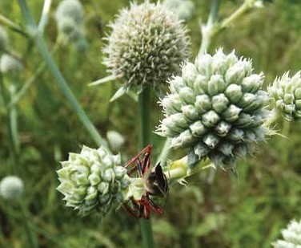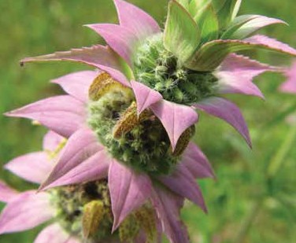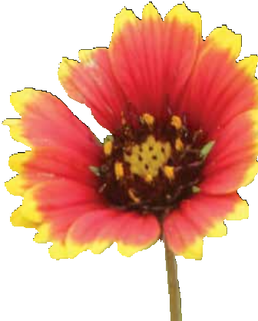4.
PLANT OR SEED .
Purchase small plants or seeds sourced locally, if possible.
Local resident and migrant pollinators have adapted over thousands of years to local plants.

Using small plants will produce faster results. Transplants must be watered until the roots are established. For larger area, seeding is less expensive. Seeds are best planted in fall or early spring. Use a mechanical broadcaster or hand spread seeds like chicken feed, then use a roller or step and
dance on the seeds to ensure good seed to soil contact. Water the area and keep watering until seeds germinate
and seedlings become established. If using seeds, add a few transplants
for instant visual effects until the seeds germinate and grow.
5.
MAINTENANCE TIPS .
Weed, trim and water until the plants become established. Cut the vegetation back to about 8 inches in January or February so that plant seeds provide food for winter birds and remove dead plant material in time for the sun to reach new spring growth. Learn to recognize desired seedlings and spring shoots of perennials, so they are not removed as weeds. Most plants will tolerate pruning, if they get leggy. If reseeding is desired, allow seed heads and seed stalks to mature (to turn brown
or tan). Leave mature seeds on the plant as food for wildlife. No need for pesticides or fertilizer!

6.
BE A GOOD NEIGHBOR.
If the native pollinator bed is to be in the front yard, learn about your local “weed” ordinance and HOA rules. For example, in the City of Houston plants between the sidewalk and curb must be fewer than 9 inches tall, or you will need to obtain a Natural Area Permit. Add borders and signage, if allowed, to make the garden seem intentional.

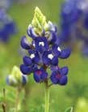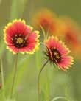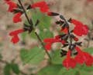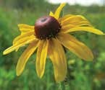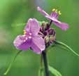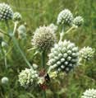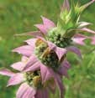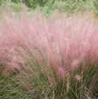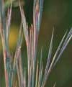
1 Natives For Your Garden
- TEXA S BLUEBONNE T, Lupinus texensis
Reseeding annual that blooms with a cluster of blue pea-like flowers with white tips in March to May. Grows 1-2 ft. tall in sun and sandy or clay soil. Our state flower is larva host for butterflies and may be toxic to humans or animals, if ingested. Reseed or plant transplants
2 in fall.
- SC ARLET SA GE, Salvia coccinea
Reseeding annual or perennial with red tubular flowers that bloom from spring to the first frost. Grows 1-3 ft. tall x 1-2 ft. wide in sun, part shade, and shade. Tolerates moist to dry soils. Very tolerant of frequent trimming to keep plant bushy. Provides nectar for hummingbirds, bees, and other insects.
3
- INDIAN BLANKE T, Gaillardia pulchella
Reseeding annual or short-lived perennial with red, yellow, brownish-centered, daisy-like flowers that bloom from spring to the first frost. Grows 1-2 ft. tall x 1 ft. wide in sun or
4 part shade; prefers well-drained, sandy soils. Cut back when leggy, leaving some stems until seedhead matures. Water in summer to prolong bloom. Pollen source.
- PRAIRIE SPIDER W OR T, Tradescantia occidentalis
Perennial with clusters of blue or pink, 3-petalled blooms that open spring to summer. Grows 2-3 ft. tall x 1 ft. wide in sun to part shade in moist to dry, sandy or clay soils. Water
before soil becomes too dry to prevent summer dormancy.
5
- BLA CK-EYED SUSAN, Rudbeckia hirta
Reseeding annual or short-lived perennial with yellow, dark-centered flowers that bloom from late spring to fall. Grows 2-3 ft. tall x 1-2 ft. wide in full sun and in dry to moist, well- drained soil. Larva host for butterflies; provides nectar for pollinators and seeds for birds.
6 6. LEMON BEEBALM, Monarda citriodora
Reseeding annual with whorled lavender-pink to white flowers; blooms May - July or into
fall, if watered. Grows 12-30 in. tall x 12 in. wide in sun or part shade, tolerates dry soil of any type. Nectar source. Plant has lemony aroma.
- RATTLESNAKE MA S TER, Eryngium yuccifolium
Perennial with yucca-like foliage and clusters of greenish-white, 1-inch thistle-like globular flowerheads cresting above the foliage during May - August. Grows in full sun and in moist well-drained soils. One of the best pollinator attracting wildflowers. Self-seeder.
- GULF MUHL Y, Muhlenbergia capillaris
7 Perennial bunchgrass with stunning pink/purple feathery blooms in October that turn tan in winter. Grows 2-3 ft. tall x 2-3 ft. wide in sun and is adaptable in moist to dry, sandy or clay
soils. Only maintenance required is cutting to about 8” tall in January or February.
- LITTLE BLUES TEM, Schizachyrium scoparium
Perennial bunchgrass grown for its structure – a dense clump of colorful stems that ranges
8 from blue-green in late summer to golden rust in late fall. Grows 1.5-3 ft. or taller in sun or part shade and in dry, sandy or clay soil. One of the dominant climax grasses of the prairie,
it’s a larva host for skipper butterflies and its silver-white seeds provide food for small birds.
BROCHURE PHOTOGRAPHY BY: Chuck Duplant, Katy Prairie Conservancy | Carolyn Fannon, Lady Bird Johnson Wildflower Center | Jaime Gonzalez, Katy Prairie Conservancy | Randy Heisch, Lady Bird Johnson Wildflower Center | James Garland Holmes, Lady Bird Johnson Wildflower Center | Greg Lavaty, Katy Prairie Conservancy | Ray Matthews, Lady Bird Johnson Wildflower Center | Michael Morton, Katy Prairie Conservancy | Sam C. Strickland, Lady Bird Johnson Wildflower Center | Kelly Walker, Houston Chapter Native Prairies Association of Texas | Sally and Andy Wasowski, Lady Bird Johnson Wildflower Center
9

